On 15th May 2017, I decided to make a change in my life that will have a small impact on me but a large impact on some people I have never met. I am really excited about this opportunity and want to share it with you.

The ongoing struggle of the poorest people in the world rarely gets a mention on the news or in national political decisions, even though it outweighs the suffering in many of the stories that dominate the news. Yet there is no moral difference between the value of a child in Burundi and a stranger you meet in the UK. If you could save a stranger's life in the street but it meant you had to ruin your new shoes or break your phone, you would still do it, because we put moral value on strangers' lives. So if we would sacrifice a small amount to save someone whose life was in jeopardy before our very eyes, shouldn't we save someone's life 10,000 miles away if we could at a similar cost? Of course we should. The reality is that we have the opportunity to do this everyday! We have a wonderful opportunity to make a huge difference to the lives of hundreds of people who are most in need.

This is very exciting to me: that I can have such a positive impact on those most in need. So, after much consideration, I have pledged to donate at least 10% of my income to the most effective causes for the rest of my life. I have joinedgrowing community of effective altruists who have made a lifetime pledge to support the most effective giving opportunities[*](http://127.0.0.1:8000/posts/giving-what-i-can/#*). [Giving What We Can](https://www.givingwhatwecan.org/) are a not-for-profit organisation that promotes the idea of effective giving and provides a platform for individuals to publically pledge to do this.  This is the Giving What We Can [pledge](https://www.givingwhatwecan.org/pledge/):

“I recognise that I can use part of my income to do a significant amount of good. Since I can live well enough on a smaller income, I pledge that for the rest of my life or until the day I retire, I shall give at least ten percent of what I earn to whichever organisations can most effectively use it to improve the lives of others, now and in the years to come. I make this pledge freely, openly, and sincerely.”

Why?

The amount of suffering in the world is astounding. One in nine people live on less than $1.90 (in purchasing power) and therefore cannot afford enough food to meet basic nutritional requirements.[[1](http://127.0.0.1:8000/posts/giving-what-i-can/#WBG16)] The suffering endured through the torture and slaughter of 70 billion sentient land animals per year for food is immense.[[2](http://127.0.0.1:8000/posts/giving-what-i-can/#ciwf17)] This suffering of humans and animals has the potential to increase massively for future generations as global catastrophes such as climate changecontinue to develop.

By supporting the most effective giving opportunities, I can use a portion of my income to significantly reduce this suffering without any meaningful reduction in my own wellbeing. More information about the philosophy and rationale of effective altruism can be found [here](http://www.matthewallcock.co.uk/posts/effective-altruism).

Why publicise this?

To donate publically has more impact than donating silently. Here's why.

We are social creatures. By making this pledge publicly, I can, add to a culture of giving effectively. If just one other person decides to take this pledge and donate considerably more and more effectively because of my influence then my positive impact on the world is effectively doubled.

Thinking more introspectively, by making this pledge public I am more accountable to maintain at least this amount of giving and therefore I am more likely to stick to it, which is clearly a positivething. The pledge is not law-binding, of course, and there will be no-one knocking at my door to check that I am donating, but it will give me the motivation to maintain a consistent level of giving.

Finally, I am very much a fan of the scientific method, *i.e.* changing beliefs, actions, theories, and conclusions based on new evidence. I am also a fan of peer reviewing, where people in the wider community assesses the correctness of other people's ideas. By publicising my actions that attempt to make the world a better place, I am opening myself up to new information, evidence, and logic that might convince me to adjust my actions. This is also a hugely positive thing which will help me help the world. On that note, if you do have any way you think I could improve, please let me know! You can do this [here](http://127.0.0.1:8000/contact/), anonymously if you wish.

Where will the money go?

The most effective charities are around 1000 times more effective than those charities that are popular and well known to the general public.[[1](http://127.0.0.1:8000/posts/giving-what-i-can/#ten95)] For the same reason that a successful investor spreads his or her money accross a range of different investments to minimise the impact of one of them collapsing, I plan to donate to several of the most effective causes. These will span the cause areas of reducing global poverty, reducing the suffering of factory farmed animals, and sharing the ideas of effective altruism to others. I will be setting up a page on my website that logs my donations for those interested!

[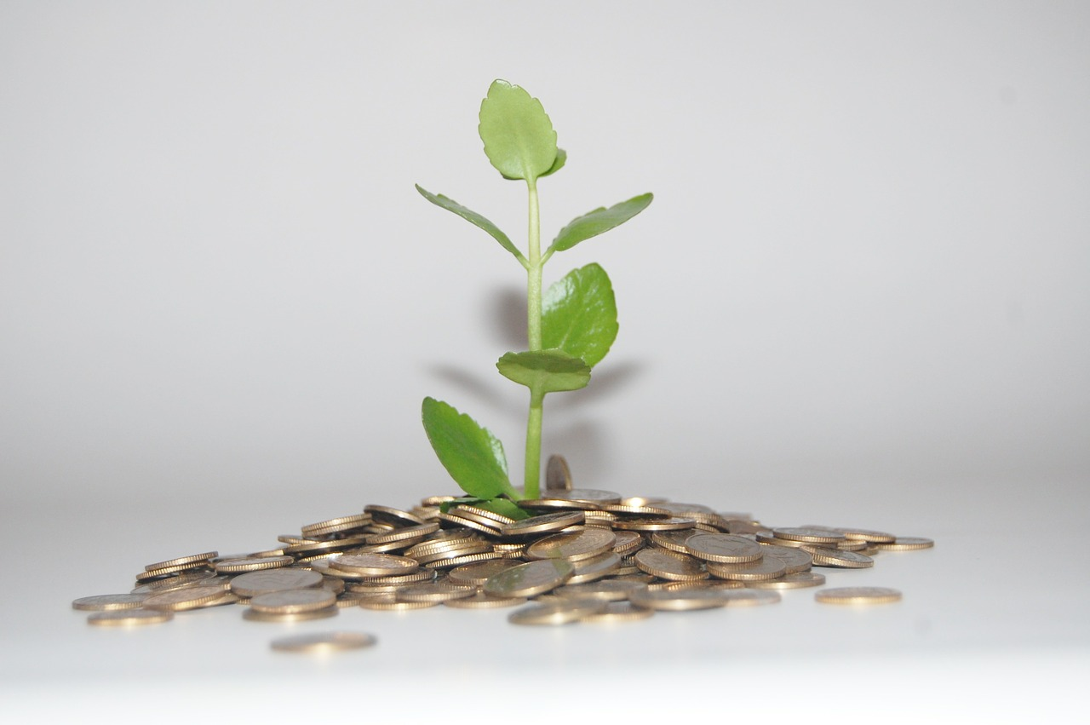](http://127.0.0.1:8000/money-plant.jpg)

Isn't that a lot of money?

The short answer is: No.

My current income puts me in the wealthiest 3.7% of the world, a surprising figure considering I am a PhD student in the very early stages of my career.

(click [here](https://www.givingwhatwecan.org/get-involved/how-rich-am-i/) to find out how wealthy you are on a global scale, it might be surprising).

The crux is, there are vast vast amounts of people living in the world that only see a slither of the international pie.

Even after I donate 10% of my income, I will be in the wealthiest 4.6% of the world. Given that I can use my income to vastly improve the lives of others donating a proportion of my income effectively is a natural consequence of aligning my actions with my philosophy.

I guees , however it is not a significant dent to my level of affluence

Is this the best I can do?

This is the commitment I am prepared to make at this time. Donating 10% of my income represents a large amount of money over my lifetime but I am confident I can maintain this commitment for life.

The success of goal setting is in creating a good match between aspiration and achievability. My aspiration would be to donate more than 10% of my income in my lifetime. current greater giving

Can you do this too?

Absolutely! However, this is not something to be taken lightly and a great deal of thought should be put into it. If you think something like this would interest you or you have any questions about it then please feel free to get in touch either in the comments below or privately through my [contact page](http://127.0.0.1:8000/contact/). You might also be interested in the FAQs about the Giving What We Can pledge, these can be found [here](https://www.givingwhatwecan.org/about-us/frequently-asked-questions/).

You might want to make a one off donation or try out just a month a year of effective giving, rather than jumping in with a lifetime pledge. You could [Try Giving](https://www.givingwhatwecan.org/get-involved/try-giving/) to help relieve the most suffering in the world from their suffering. You have the power to help by giving effectively... you might even enjoy it!

Footnotes

*The most effective uses of money for reducing global suffering are not necessarily charity donations which is why I am sticking with the term 'giving opportunities' rather than 'charities'. For example, funding for scientific research in a particular area such as climate change or safe artificial intelligence development could reasonably be deemed to be most effective at reducing suffering, and this is not an area of charity. This is known as 'existential risk reduction' and is thought to be the most effective way to reduce suffering in the long-term by a number of effective altruists.

** This calculation is based on the median monthly donation of £14 and the median annual income of £27,600 in the UK in 2015. [[4](http://127.0.0.1:8000/posts/giving-what-i-can/#CAF15)][[5](http://127.0.0.1:8000/posts/giving-what-i-can/#ONS15)]

Bibliography

This year I decided to make a big change in my life to try and make the world a better place to live. Being fortunate enough to living in one of the world’s wealthiest nations can make us blissfully unaware of the suffering in the world. Yet we have such power to help. This is what I am trying to do.

I decided to make a big change in my life to try and make the world a better place. Check out what it is in my new blog post